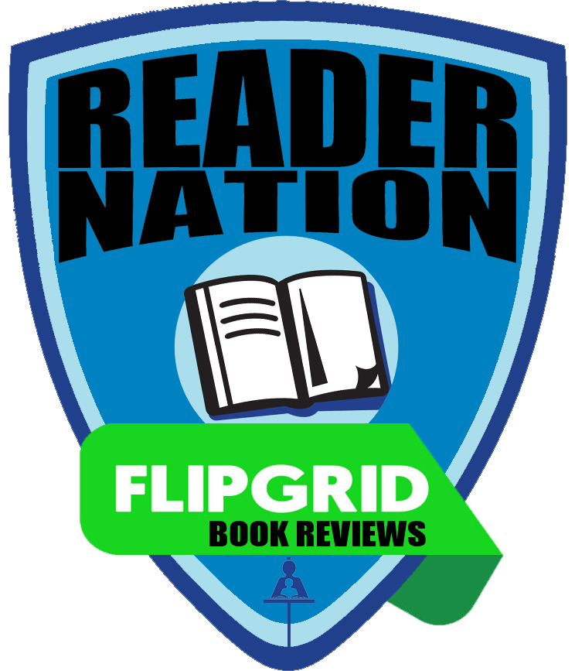
REVIEW | REFLECT | RATE | RECOMMEND
BOOK REVIEWS

- Open Flipgrid
- Use the code rcsdbook
- Enter the student ID or scan
the QR Code given to you

- Select your grade level

- Click to add your video
- Click to record your video. Wait for the countdown.
- Sentence Frames:
  - This book is very ___________ (funny, sad, scary, etc) because…
  - I liked this book because…
  - I did not like this book because…
  - I enjoyed this book because…
  - This book wasn’t very good because…
  - My favourite character was ___________ because…
  - I wouldn’t recommend this book because…
  - This book is about… (main idea only!)
  - An interesting part of this book is…
  - I learned that…
  - I gave this book ____ stars because…


- Click to pause/resume your recording

- Click to review your response

- Can you hear yourself clearly? If not, click to re-record
- You can click to trim your video from the beginning or the end

- Click if you are satisfied with your recording
- Click to snap your selfie with your book
- Click to proceed
- 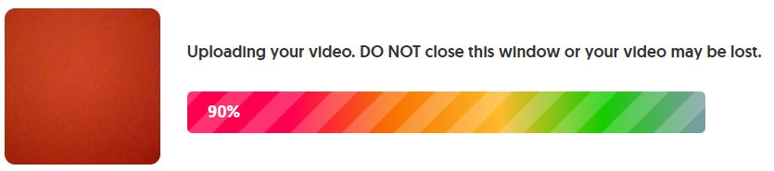Wait for your video to be uploaded
- means your video is uploaded
- 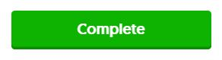Click

Once your teacher librarian has viewed your video, it will appear on the #RCSDbook grid for others to view!

