HOW TO SIGN OUT A BOOK

If the computer is not logged in, log in to the circulation account.
USERNAME: circ21
PASSWORD: library

STEP 1: Open Destiny

STEP 2: Click LOG IN on the top right hand side of the page.
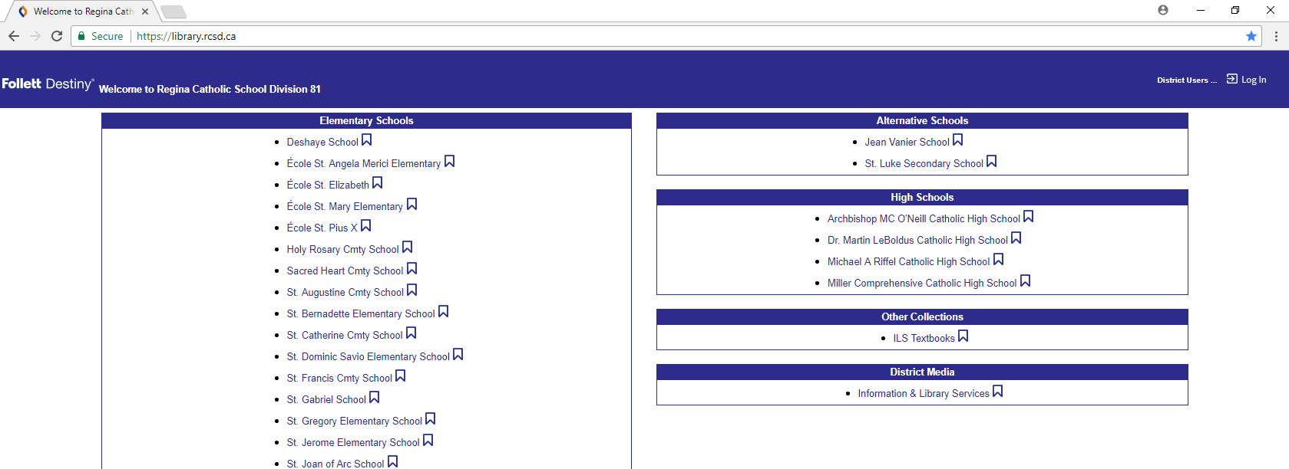
STEP 3: Type in the username and password.
USERNAME: staff01
PASSWORD: ilmrc
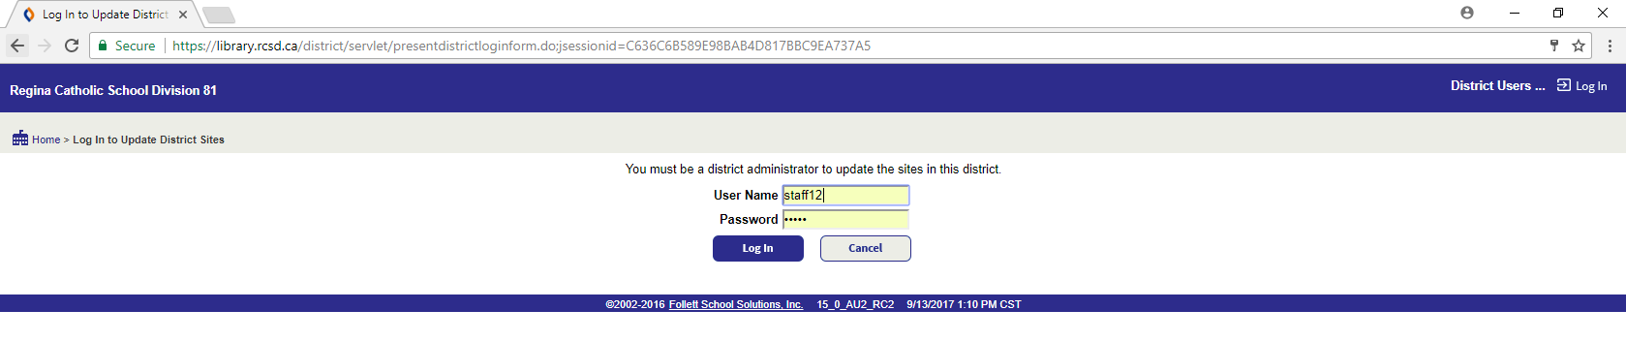
STEP 4: Click Circulation
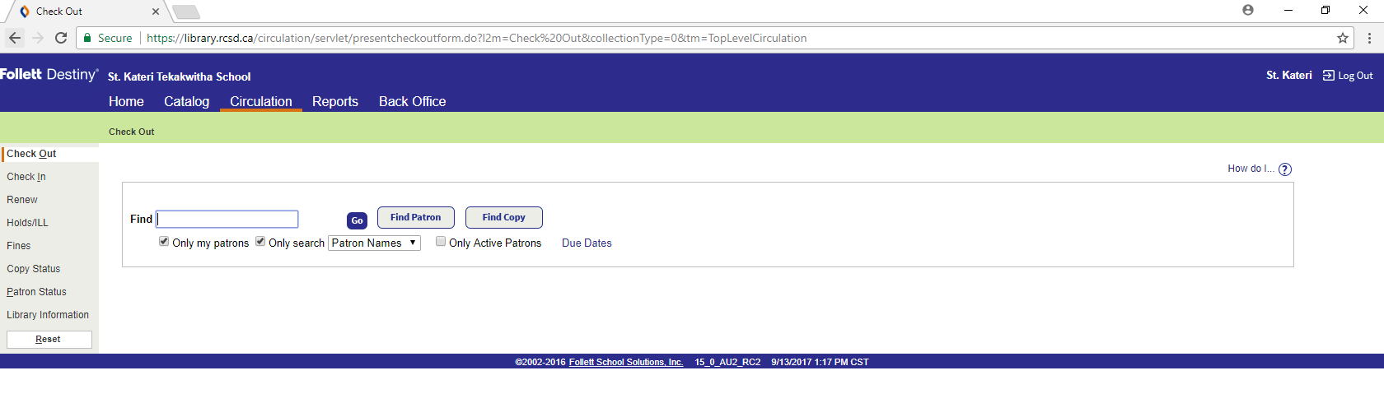
STEP 5: Scan Patron Barcode (you can also type their name if they forget their library card)
STEP 6: Scan all books, check to see that the book appears on their name (you should hear a ding)
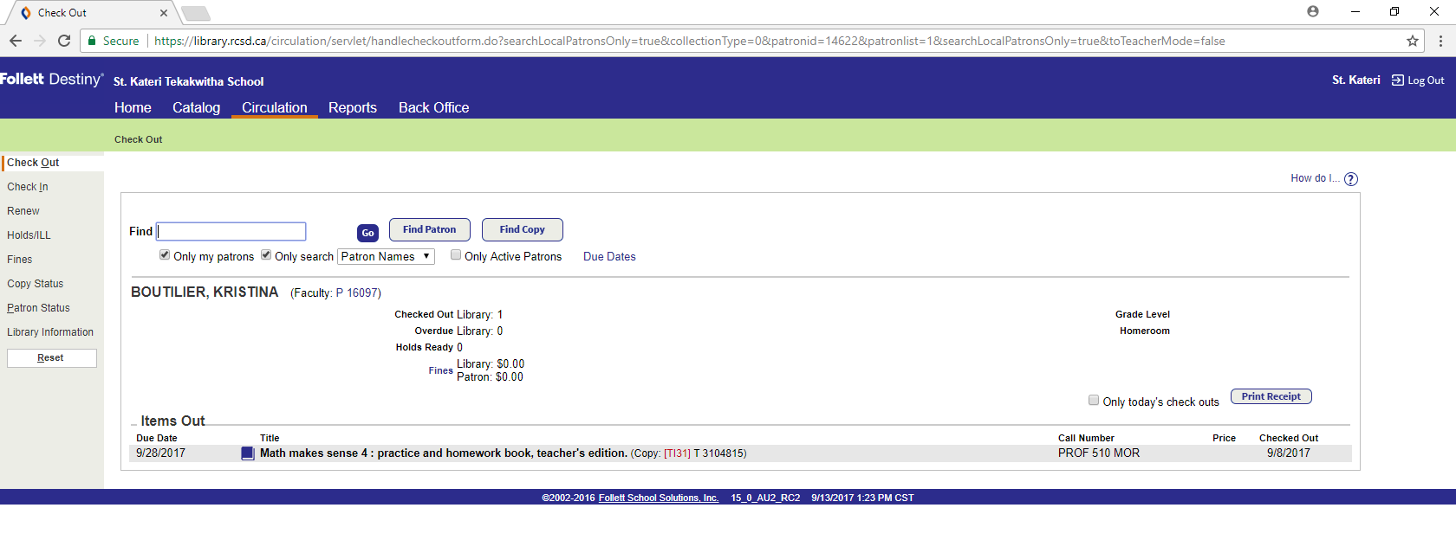
STEP 7: After you have checked out all books, click RESET

