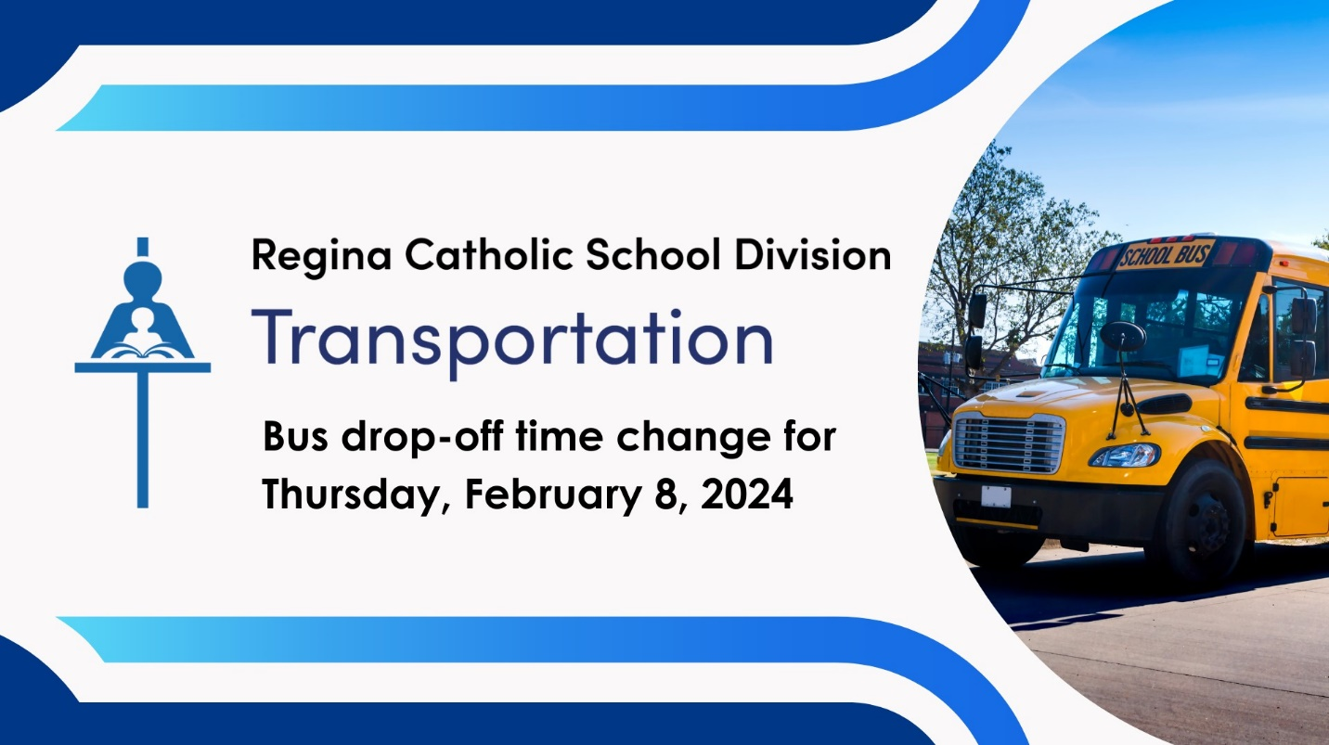

Deshaye School – Bus Students
- Students dismissed at 1:46 p.m.
- Buses will begin to depart at 1:55 p.m, which is 1 hour, 50 minutes early.
- Students dropped off about 1 hour and 50 minutes early. For example, if your child is usually dropped off at 3:50 p.m, you can expect your child at their bus stop at about 2:00 p.m.
- These temporary changes to mid-day and afternoon runs will not show in the Parent Portal
- GPS will not be available in FirstView for PM drop-off.

