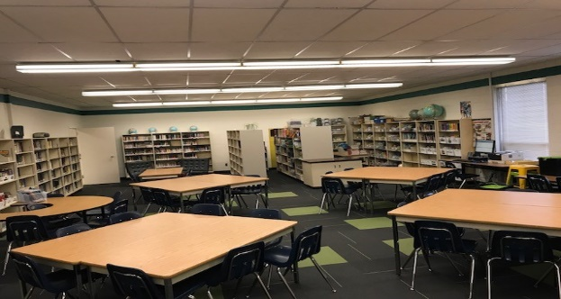
Welcome to the Library!
My name is Hannah Patterson and I am your teacher-librarian at Deshaye! I have been teaching for 17 years. This is my 7th year as a teacher-librarian.

As the teacher-librarian, I am responsible for the school library program, collection, and facility. In addition, I collaborate, plan and teach with teachers, work with students, and help to create 21st century learners who are transliterate.

The library program has some exciting opportunities in store for your child this year:
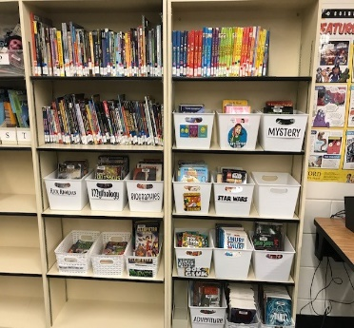
- One of my goals for your children is to instill a love of reading! Whether they are light readers or completely obsessed, our library program will encourage them to read more and broaden the scope of their reading.
- I will help students inquire, evaluate, create, and share as respectful and responsible digital citizens.
- I will be working with classroom teachers to help them find materials especially suited to the individual interests and abilities of your child.
If you would like to volunteer to help in the library, please let me know. I’d love to have you! If you are a parent, please email me at h.patterson@rcsd.ca If you are a student helper it will be a bit different this year. Students must sign up to be a helper and will be on a 3 day rotation in the library. I will partner my helpers up, have them sign in and teach you the ropes. Please let me know after orientation if you would like to be part of this team
I look forward to meeting you at some of the events that will take place in the library such as, literacy nights, a book fair, and literacy initiatives. I am committed to making the library one of your child’s favorite place in the school!
Mrs. Hannah Patterson

Follow me on: @coachpatty1

Deshaye Library Procedures
- Be kind and respectful to teachers, fellow students, and of course the BOOKS. Be honest and let me know if you find a damaged book so I can replace it or let me know if something happened to it in your care.

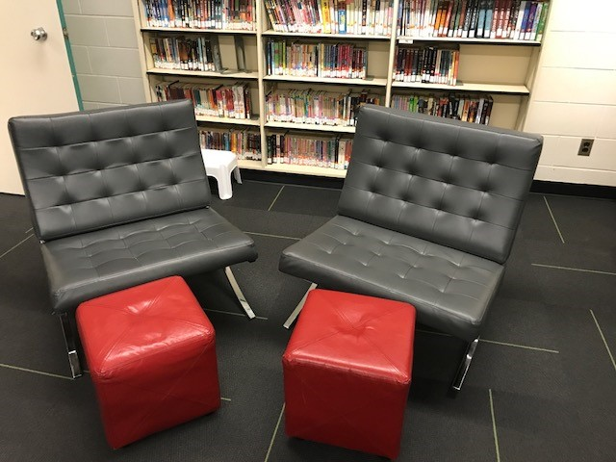
- Please be quiet while the class is reading or while Mrs. Patterson is teaching.

- Always use your library voice.

- Walk.

- Always follow the check-out procedures. If you need help ask your classroom library helper or teacher.

- Please return books NICELY into the Book Return bin.

- If you look at a book, but don’t sign it out, please put it in the red bucket or in the correct spot on the shelf.

- Please use shelf markers at all times! Magic sticks make it so much easier for Mrs. Patterson and you

- If Mrs. Patterson needs your attention, she will raise her hand and count down from 3.

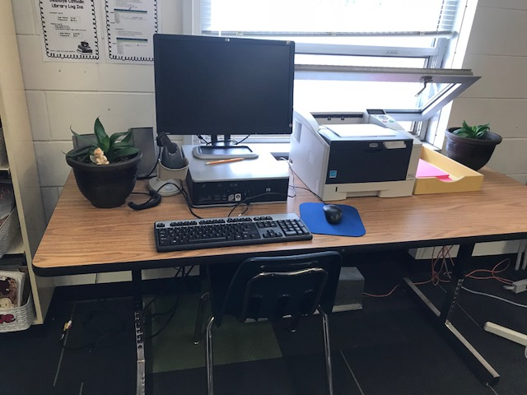
- Always leave the library neat and tidy – push in all chairs, return all soft seating, make sure all books are picked up off the floor, books are neatly lined up on the shelves with spines out.

Tidy the library!

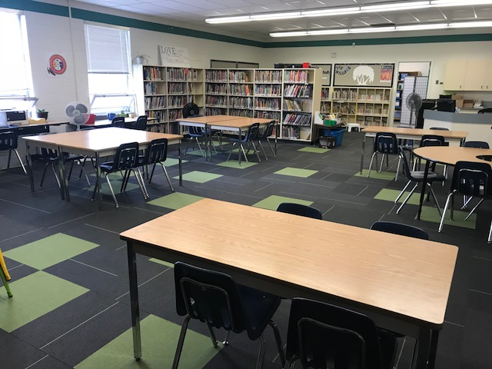
Book Check-Out Procedures
- Return your old books. You can only have 3 books checked out at a time. Your teacher may help you in the primary grades. Some people will have sticks with a barcode and some will have their barcode on their agenda. If you are in the library looking for a book, your agenda or stick must be in your hand. If you come for open book exchange without it you will not be able to sign out a book.

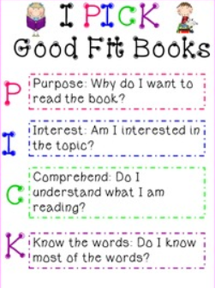
- Find your awesome new BOOK! Try Using the IPICK Good Books procedure

- Quietly line up at the library desk with your library barcode ready and books with barcodes up for primary students. Older students may independently sign out books but need to remember to “reset” after. Please use the window computer older students.

- A teacher or trained library helper will sign out you books. If you are unsure or the computer has not been logged in. Older students may start circulation up for me using the posters on the wall.

- Quietly sit down at your spot and start reading.

- Overdue Books – if you have an overdue, you cannot take out a book until it’s returned. If you lose a book or damage one, Mrs. Patterson will send a letter home. Payment will be expected ASAP.

