Tabata
 | 20 secs on – 15 secs rest
1 | 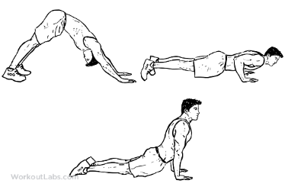  Dive bomber push ups
2 | 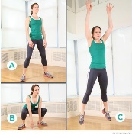  frog jumps
3 |   sprint (on the spot or outside …do short intervals 20 m sprints if outside)
4 | 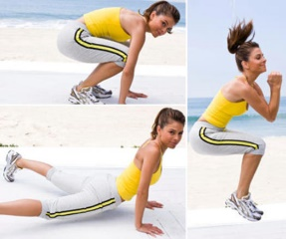  sprawls, step back, two foot jump hips to the floor
5 | 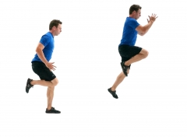  Jump right foot across the room and left on the way back (if outside use 10 m)
6 | 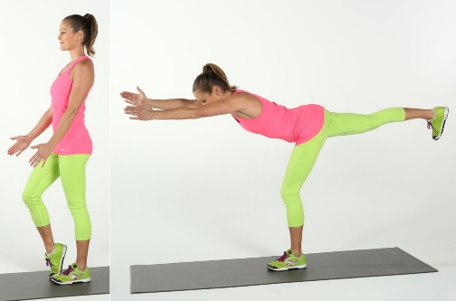  Bend knee and bring leg back balance
7 | 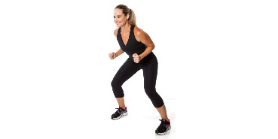  Shuffle
8 | 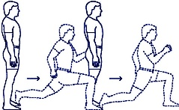  walking lunge


